Floyd’s of Fargo Data Game
Teacher Facilitation Guidelines

If you have not done so already, please watch the short student and teacher videos, and play Floyd’s of Fargo before or as you read these notes. Also, you should look at the student worksheet for Floyd’s of Fargo.
Learning Goals
- This game offers a rich learning environment and multiple possible goals:
  - Advanced goals – Students develop their skills with creating and interpreting linear and quadratic models, and their understanding of probability, expected value, and variation. With this approach, students develop and analyze the quadratic profit function and determine the expected values for the optimal premium price and ending balance.
  - Less ambitious goals – Students develop their informal understanding of linear and quadratic models, probability, expected value, and variation. In this more empirical approach, students focus on data analysis by running simulations to find the best premium price for the maximal ending balance. They don’t necessarily try to write equations for each of the functions.
  - Hybrid goals – Students who have some experience with quadratics can approach the problem empirically and then informally using the graph to fit a parabola to the profit function (without necessarily understanding why it’s quadratic or writing a function for the quadratic).
- The relevant CCSSM standards are listed at the end of this document.
Prior to Students Playing
- Consider whether to facilitate the activity using a directive approach or a more student-directed exploration. The approach and the learning goals you choose will determine the number of class periods needed.
- The student worksheet guides students in first finding the best premium price through an empirical trial-and-error approach. Then the extension section guides them toward the mathematical proof, as stated in the advanced learning goals listed above. You can modify the worksheet for your particular learning goals and students.
- Although some students may be familiar with the basic ideas behind insurance, classes will most likely benefit from an overview of how companies make money in this type of business. You should review the topics of price-setting, probability, and profit/loss. These ideas are introduced in the video. This simulation of an insurance business has been simplified, of course, from the real world, to help students focus on the desired mathematical topics.
- For suggestions on how to prepare to play Data Games with students, go to the Teacher FAQ section of the Data Games website
(http://play.ccssgames.com/faq-page).
During Gameplay
- Overall notes
  - The student worksheet divides the activity into a number of major steps. The sections in these teacher notes reflect these major steps.
  - In this simulation, the premium alone determines the number of customers: the lower the premium, the more customers you get. This does not fully represent the real world of insurance or of supply and demand, of course; but this keeps the variation in the game isolated to the number of flats, and so makes it a more reasonable situation for students to model.
  - Encourage students who draw conclusions from only a small data set to continue running simulations to collect better evidence to support or contradict their conjecture. Explore students’ ideas about variation and the influence of probabilities. This may be a good time to introduce or reinforce probability’s Law of Large Numbers.
  - Students might experiment with creating a colored legend in some graphs by dragging a third variable into the center of the graph, which can help them visualize other relationships in the data.
- “Try selling at various premium prices” worksheet section
  - Students will see that a premium price of $1.00 or higher attracts no customers.
  - Clicking Auto Finish plays all remaining turns by selling at the current price.
- “Play several more games, and then look at what’s going on with your business” worksheet section
  - After students have performed the steps and answered questions through Q8 in the worksheet, you might get the whole class back together for a discussion. Or you could answer questions Q4–Q8 together. Review their responses to the questions using a sample case table, practice applying the terms, and support their understanding of the relationships.
- “Compare highest revenue with highest balance” worksheet section
  - Check in on student responses to worksheet questions Q9–Q12 with the whole class or in smaller groups.
- “Find the premium price that makes you the most money” worksheet section
  - Students can collect data by changing the price one cent at a time, using Auto Finish for each, and creating a graph with endBalance and lastPrice in it. The data is noisy, but they can see a parabola emerge and look at the vertex region.
  - Students can use Plot Function on the endBalance – lastPrice graph and try to create a function to model the situation, as below:
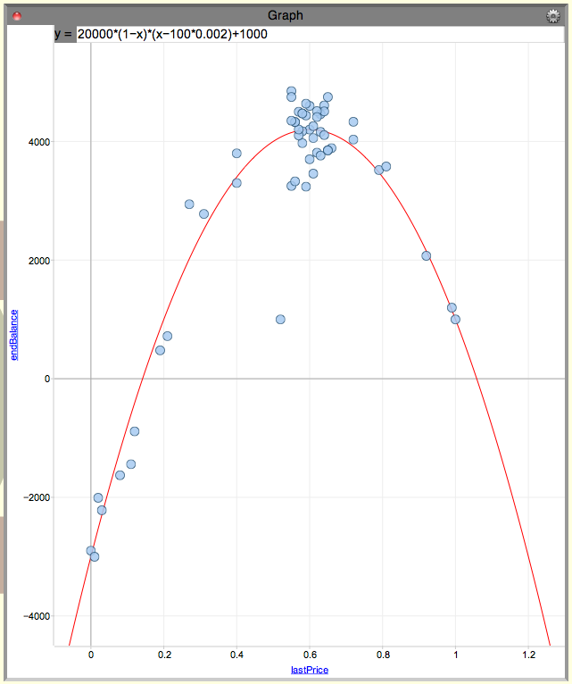

- “Extension Section: Develop an Explanation for Your Best Price”
  - The remainder of the student worksheet guides them partway to a mathematical explanation for their best price.

- “Premium price and number of customers” worksheet section
  - The relationship between customers and premium price here is linear, with a negative slope. At a price of zero, the number of customers is 2000. This number declines until it hits zero when the premium is $1.00.
  - Customers per turn can be described by:
[1] customers = 2000 x (1 – price)
or, distributing:
[2] customers = –2000price + 2000
  - Here is a price – customers graph and a movable line that fits it:
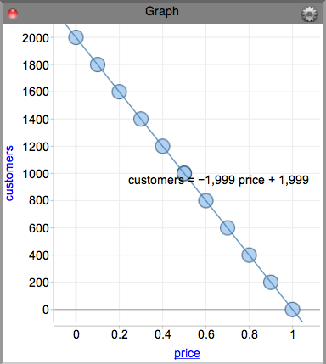
- Students will sometimes end up with equations like this when they drag their lines, and need to examine the data they’ve collected and decide whether to round. Here, since price = 0 gets 2000 customers, and price = 1 gets 0 customers, we should round both 1999’s to 2000.
- “Probability of getting a flat”
  - There is a fixed probability (about 0.002) for each car to have a flat. This is the only place where variation enters directly into this simulation.
  - Students won’t know the 0.002 value for the flats probability until they determine it by running simulations. The expected value for flats can then be described by:
[3] flats = 0.002 x customers
or, using equation [1] above to substitute for customers:
[4] flats = 0.002 x 2000 x (1 – price)
or, distributing:
[5] flats = –4price + 4.
Notice that flats is a linear function of price.
  - Students can find this probability by creating a totalCust – totalFlats graph, and fitting a movable line to the data, as shown below. The constant ratio between totalCust and totalFlats is the slope of the line, and gives the probability of any customer having a flat.
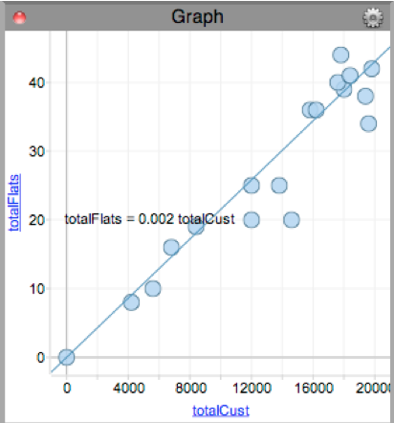

- Revenue per turn can be described by:
[6] revenue = customers x price
or, using equation [1] above to substitute for customers:
[7] revenue = 2000 x (1 – price) x price
or, distributing:
[8] revenue = –2000price² + 2000price
Notice that revenue is a quadratic function of price.
- Payout per turn can be described by:
[9] payout = flats x 100
or, using equation [4]:
[10] payout = 0.002 x 2000 x (1 – price) x 100
or, distributing:
[11] payout = –400price + 400.
Notice that payout is a linear function of price.
- Profit per turn can be described by:
[12] profit = revenue – payout
or, substituting using equations [7] and [10]:
[13] profit = 2000 x (1 – price) x price – 0.002 x 2000 x (1 – price) x 100
or, factoring:
[14] profit = 2000 x (1 – price) x (price – 100 x 0.002)
or, simplifying:
[15] profit = 2000 x (1 – price) x (price – 0.20)
Notice that profit per turn is a quadratic function of price.
(Also note that profit is not a variable included in the table. So if students want to see it, they will need to go to the Table’s Gear menu, choose New Attribute in Turns..., and then create it along with a formula.)
- This factored profit function [15] is a parabola with zeros at price = 1 and price = 0.20, so its vertex is halfway between them at price = 0.60. This then gives the expected maximum profit per turn of $320.
- A graphical representation of the revenue, payout, and profit functions:

Note that the taller parabola (revenue function) minus the line (payout function) gives the shorter parabola (profit function). The maximum expected profit per turn is at the vertex of the profit parabola, (0.60, 320).
- The graph above can increase students’ understanding of the situation. It visually highlights the fact that profit is not maximized by the same price as revenue, by showing that the parabolas’ peaks aren’t lined up vertically. This is because the payout line slants downward to the right, so you’re subtracting less when price = 0.60 than at 0.50.
- The endBalance for the game can be found using profit for the 10 turns:
[16] endBalance = 10 x profit
or, using [15] to substitute for profit:
[17] endBalance = 20000 x (1 – price) x (price – 0.20)
Notice that endBalance is a quadratic function of price.
- The maximum expected value for endBalance = 10 x 320 = $3200. Of course it can vary above this if there are a smaller number of flats than expected.

Challenges Introduced on Each Level
- Floyd’s of Fargo only has one level.
Answers to Student Worksheet Questions
- “(Q1) How many cars passed by each time?” – 2000
- “(Q2) Did the same number of flats occur each time?” – No
- “(Q3) What is the highest endBalance you’ve earned in your games so far?” – Answers will vary.
- “(Q4) How is the value for revenue being determined? Explain here.” – Number of customers times premium price
- “(Q5) How is the value for payout being determined? Explain here.” – Number of flats times 100
- “(Q6) How is the value for balance being determined? Explain here.” – Revenue minus payout plus previous balance
- “(Q7) If you play two games using the same premium price, do you always end up with the same balance?” – No
- “(Q8) Why do you think this happens?” – Even though the number of customers remains constant with the same premium price, there is variation in the number of flats, so you have different payouts and therefore different balances.
- “(Q9) Out of all the games you’ve played, what is the highest revenue you’ve earned so far?” – Answers will vary, but it should be getting close to $500.
- “(Q10) Which premium price that earned that highest revenue?” – Answers will vary, buy it should be getting close to $0.50.
- “(Q11) Does it look like the same price that creates the highest revenue also creates the highest balance?” – No
- “(Q12) Why do you think this is?” – See graph and explanation above. You have fewer customers, so you subtract less in payout when price gets higher.
- “(Q13) What do you think is the best premium price?” – Answers will vary, but they should be close to $0.60.
- “(Q14) What is your end balance with that best premium price?” – Answers will vary, but it should be getting close to $3200.
- “(Q15) How many customers do you get if you give the insurance away for free?” – 2000
- “(Q16) At what price will you no longer get any customers?” – $1.00
- “(Q17) Is the number of customers a function of the premium price?” – Yes
- “(Q18) If so, what type of function is it?” – Linear
- “(Q19) What is the equation that fits your data?” – customers = 2000 * (1 – price) or customers = –2000 * price + 2000
- “(Q20) Figure out the probability of any given customer getting a flat.” – 0.002
- “(Q21) Write an equation relating the expected number of flats to the number of customers.” – flats = 0.002 * customers
- “(Q22) Use your Q19 and Q21 responses to write the equation for flats in terms of the price.” – flats = 0.002 * 2000 * (1 – price) or flats = –4 * price + 4
- “(Q23) Continue the process above, looking at revenue, payout, profit, and end balance. Create some equations, functions and/or graphs that offer a convincing mathematical explanation that you have found the best premium price.” – Answers should refer to some graphs or algebraic work student has done, similar to that shown in the “Math Details” section above.

Relevant Common Core State Standards for Mathematics
- Investigate chance processes and develop, use, and evaluate probability models (7.SP.6)
- Interpret the structure of expressions (A.SSE.1, A.SSE.2)
- Write expressions in equivalent forms to solve problems (A.SSE.3)
- Create equations that describe numbers or relationships (A.CED.2)
- Represent and solve equations and inequalities graphically (A.REI.10)
- Use functions to model relationships between quantities (8.F.4)
- Interpret functions that arise in applications in terms of the context (F.IF.4)
- Summarize, represent, and interpret data on two categorical and quantitative variables (S.ID.6)
- Interpret linear models (S.ID.7)
- Investigate patterns of association in bivariate data (8.SP.3)
- Use probability to evaluate outcomes of decisions (S.MD.5)
- Make sense of problems and persevere in solving them (Standard for Mathematical Practice - 1)
- Model with mathematics (Standard for Mathematical Practice - 4)
- Use appropriate tools strategically (Standard for Mathematical Practice - 5)
- Attend to precision (Standard for Mathematical Practice - 6)

